Module 10:

Customizing Project Features

Contents

Module Overview 1

Lesson 1: Customize User Interface 2

Customize Quick Access Toolbar 3

Customizing the Ribbon 8

Exporting / Importing the Customization File 12

Practice: Customizing the User Interface 14

Lesson 2: Customizing Formats and Views 15

Overview of Custom Formats and Styles 16

Customizing Gantt Views 17

Customizing Timeline Views 25

Practice: Customizing the User Interface 32

Lesson 3: Working with the Organizer 33

What is an Object & What Objects are Available 34

Define Settings in Organizer 36

Using the Organizer to Share Objects 37

Practice: Working with the Organizer 39

Lesson 4: Creating Custom Objects 40

Creating a Custom Field 41

Creating a Custom Filter 47

Creating a Custom Group 50

Creating a Custom Table 55

Creating a Custom View 58

Practice: Creating Custom Objects 61

Summary 62

10

.

# Module Overview



The customizing features of Project 2010 will help to fine tune your version of Project to meet your needs. Perhaps you would like to add a button to a ribbon bar or create a custom field to hold data required for your project. You might need to know what is occurring next week or need specific formatting on a Gantt chart. These can all be created using the customization features of Project 2010.

In this Module, we will discuss:

1. Customizing the ribbon bar.
2. Export/import customized ribbon bars.
3. Customizing views.
4. Retaining customized objects using the Organizer.
5. Creating custom objects.

# Lesson 1: Customize User Interface



The ribbon interface and the Quick Access bar are new to Project 2010. Both can be customized to meet individual needs. Ribbon bars may also be imported/exported across project schedules and users.

In this Lesson, we will discuss:

1. Customizing the Quick Access bar.
2. Customizing ribbon bars.
3. Export/Import ribbon bars.

## Customize Quick Access Toolbar



The Quick Access Toolbar is a small collection of commands in the upper left corner of the Project 2010 desktop that provides quick and easy access to your most used commands. The default icon functions are: Save, Undo, Redo buttons. Additional commands can be added using the down arrow on the right side of the bar. Other options available are to move the bar under the ribbon bar or select icons from a list of popular suggested icons. Below is a view of the Quick Access Toolbar.



**To add a command from the short list to the Quick Access Toolbar:**

* Click on the **down arrow** on the right side of the Quick Access Toolbar
* Select a command
* The command is added

In the view below, the customization options have been displayed and “Open” has been selected to be added to the Quick Access Toolbar.

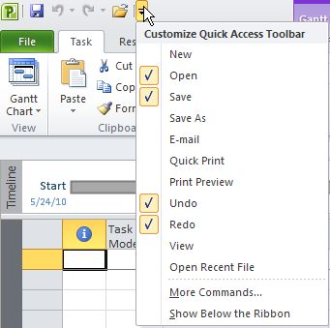

The view below shows the result of adding the Open icon the Quick Access Toolbar:



To add other commands not shown on the Quick Access Toolbar short menu:

* Click on the **down arrow** on the right side of the Quick Access Toolbar
* Select **More Commands** at the bottom of the choices
* Select a command from the list on the left and click **Add**
* Use the **Up/Down** arrows to the far right to arrange the order of appearance of commands on your Quick Access Toolbar
* Click **OK** to close

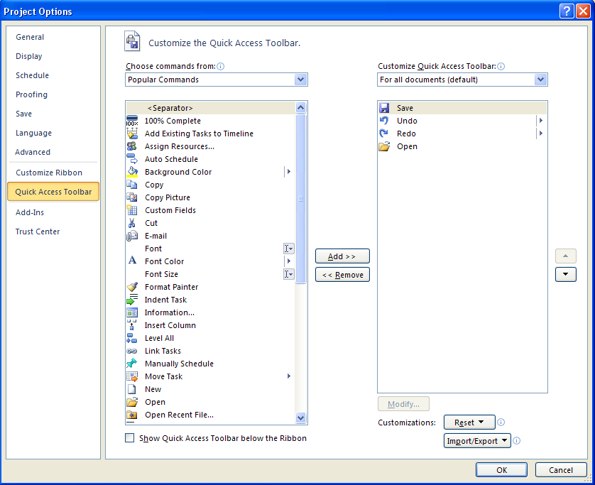

The Quick Access Toolbar default can be restored by clicking Reset and confirming you wish to do so.

More command choices are available in the drop down list in the *Choose commands from:* box and selecting from *Commands Not in the Ribbon* or *All Commands* options. Note the choices in the view below.

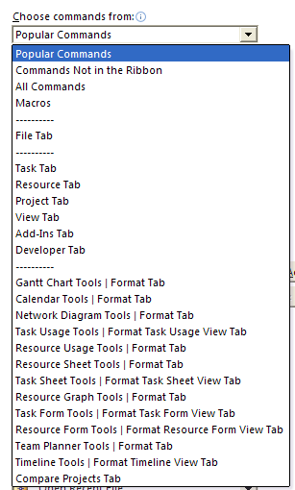

Some helpful icons to add to the Quick Access Toolbar include:

* New
* Open
* Print Preview or Quick Print
* Status date
* Scroll to task
* Task Entry View and other frequently used views
* Show Outline
* View, table, filter, grouping galleries

The drop down menus for view, group, filters, and tables can also be added to the Quick Access bar in the upper left hand corner of the screen. The instructions below are the steps to add the Filter drop down menu to the Quick Access Toolbar. Adding other galleries will use similar steps. Many of the ribbon icons may be added to the Quick Access bar using this method.

**To add a drop down menu (gallery) to the Quick Access Toolbar:**

* Task 🡪 Gantt Chart 🡪 View
* Right click on the down arrow for Filters
* Select **Add to Quick Access Toolbar**

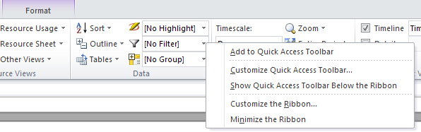

**The drop down menu** for filters on the Quick Access Toolbar is shown below:

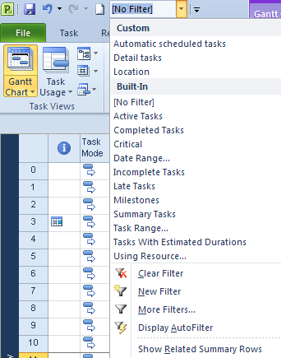

**TIP:**  *Individual items in a drop down menu cannot be added to the Quick Access Toolbar but the options at the bottom (Clear Filter, New filter, More Filters, Display Autofilter) are available. Right click on the selection and select Add to Quick Access Toolbar.*

To remove buttons from the Quick Access bar, right click on the button and select the remove option.

## Customizing the Ribbon



Each ribbon bar contains sections of related function icons. Icons from an existing section or group cannot be modified or deleted. When icons are added to a ribbon bar, a new section will be added to contain the additional icons. Additional ribbon bars may also be created. Below is a view of the Resource ribbon bar. The grouping names are at the bottom of each bar section:

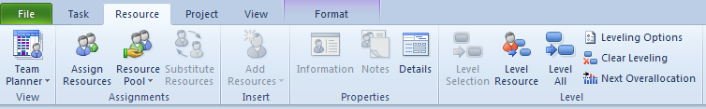

**To view the Customize Ribbon dialog box:**

* **File 🡪Options 🡪 Customize Ribbon**

On the left of the box are Popular Commands and the existing ribbon bars are shown on the right. On the right side click a **+** to expand and view the details of the bar. Each section can be expanded further to view the commands within. These sections or groups are standard and cannot be changed. An entire group of commands may be deleted (right click on the command title for option) from a ribbon bar but not an individual command.

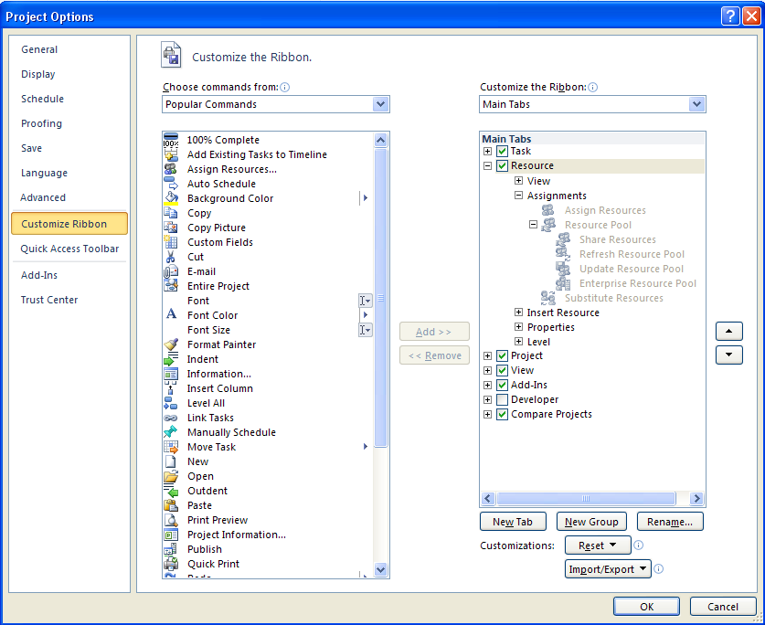

A new group or tab must be added to the ribbon before new commands can be added.

**To create a new group within an existing ribbon bar:**

* In the right side box, click on the ribbon tab you would like to add a group to.
* Click **New Group** at the bottom of the right side box.
* Click **Rename** to the right of the New Group button .
* Type the display name of the new group.

**To add icons to the new group**

* Click the group name in the box on the right.
* Click on the icon or command choice on the left.  
  More Icons are available when All Commands is selected from  
   “Choose commands from” .
* Click **Add** in the middle to add the icon to the group on the right.

In the diagram below, a new group was added to the View ribbon bar and was renamed “Scrolling”. The “Scroll to task” icon was added to the “Scrolling” group.

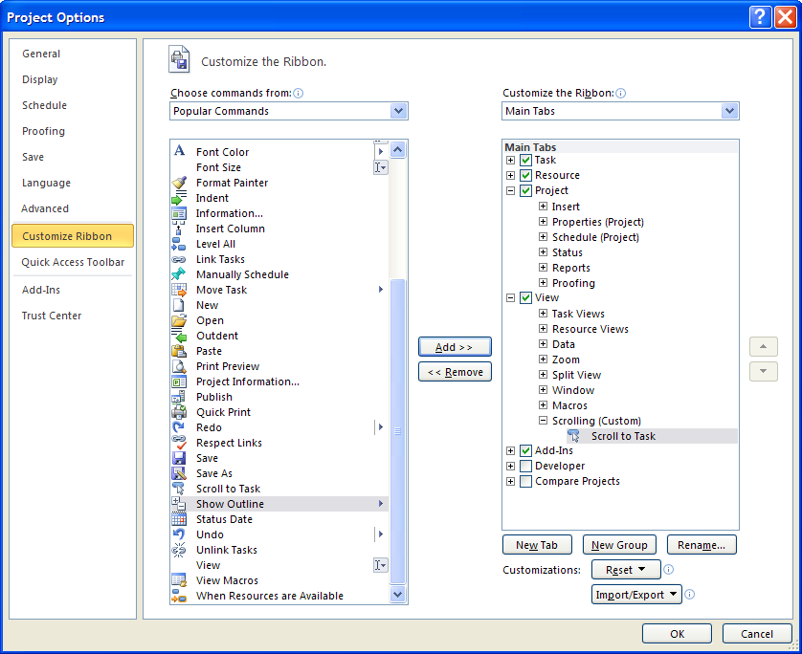

The result of the group and icon addition to the View ribbon bar is shown below. When the mouse pointer hovers over the icon button, help will be available the same way it is available for the other icons.

**TIP:** *Use short group names. Long names will determine the width of the group shown on the ribbon bar. You cannot use Undo to remove the group.*

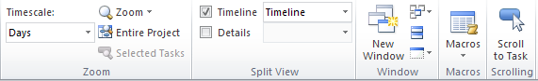

The Format bar content will change based on the view which is displayed. These unique Format bars may also be customized and are highlighted below. Click on the choices under “Customize the ribbon” on the right side and select “Tool Tabs” to display the format bars available for customization. In the view below, a new group has been added to the Format bar available when Gantt charts are displayed. The icon “Gantt Chart Wizard” (a Gantt chart formatting tool) has been added.

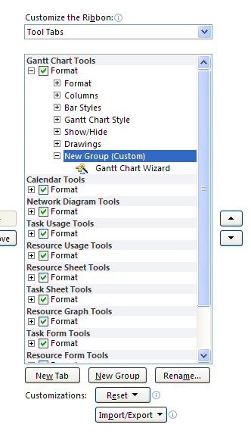

The result of adding this new group and icon to the Format bar is shown below:

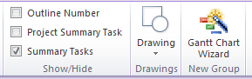

**TIP:**  *Ribbon bars can be restored to their default settings at any time using the Reset button. You can also choose to reset customizations on all ribbons or selected ribbons only.*

## Exporting / Importing the Customization File



Customizations made to the ribbon bars, will reside within your project schedules and remain with your installation of Project 2010. The customization values will be able to be accessed by all projects on your desktop. Sharing your customized configuration with others is easy and advantageous for organizations with a desire to standardize their project management process. Backing up the customized configuration is also recommended to avoid loss of data. The configuration of your ribbon bars maybe exported to a file which may be imported by other users or used if reinstallation of your software is necessary.

When the ribbon values are exported, they are exported to a default file name Project Customizations.exportedUI. This file may be used to reload your setting in the future or other users may use this file to import ribbon settings for their application.

**To export all ribbon values to an Exported Office UI file (.exportedUI).**

* **File 🡪 Options 🡪 Customize Ribbon 🡪 Import/Export**
* Click **Export all customizations**
* **Enter a file name or use the default and a file location**
* **Click Save to complete the export**

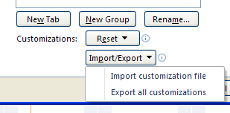

**To import a Project Customizations.exportedUI file:**

* **File 🡪 Options 🡪 Customize Ribbon 🡪 Import/Export**
* Click **Import Customized file**
* Navigate to the file location
* Select **File** and click **Open**

The following message will be returned.

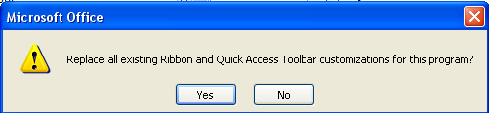

Click **Yes** to complete the import.

## Practice: Customizing the User Interface



*The Practice page is where you write detailed instructions for completing work listed as Exercises.*

*Type the Exercise Title and write a brief summary what the student will be doing in the exercise. Then list your ideas what they will be doing.*

*SAMPLE*

*In this practice you will create a Project Server Authentication profile and then configure the local cache settings in Project Professional 2007.*

*Exercise 1: Create Project Server Authentication Profile*

*In this exercise you will create Project Server authentication profile to connect to the Project Web Access site.*

Perform the following exercise on the PS07 virtual machine.

1. *From the* ***Start*** *menu, click* ***All Programs*** *🡪* ***Microsoft Office*** *🡪* ***Microsoft Office Tools*** *and click* ***Microsoft Office Project Server 2007 Accounts****.*
2. *In the* ***Project Server Accounts*** *dialog box, click* ***Add****.*
3. *In the* ***Account Properties*** *dialog box, and complete the following settings and click* ***OK****.*

|  |  |
| --- | --- |
| *Setting* | *Perform the following:* |
|  | |
| *Account Name* | *Type* ***Project Server*** |
| *Project Server URL* | *Type* ***http://epm/pwa*** |
| *When connecting* | *Select* ***Use Windows user account*** |
| *Set as default account* | *Select check box* |

# Lesson 2: Customizing Formats and Views



All views in Project 2010 can be customized and formatted to help communicate your project schedules to stakeholders. A wide range of flexible tools are available to assist the project manager in this effort. New formatting capabilities have been added to Project 2010 to complement the new features of the software. In addition, most of the customization capabilities of the older versions of Project are still available in Project 2010. Project 2010 also contains a new view called the Timeline view which allows users to customize and see their resource assignments in a timeline format.

In this lesson we will examine:

1. Overview of custom formats and styles.
2. Customizing Gantt charts.
3. Customizing the Timeline view.

## Overview of Custom Formats and Styles



Almost every aspect of a view can be modified and changed. From the character font to the colors of the Gantt bars, almost every element is format ready. Because of this extreme formatting capability, not all features can be addressed in the framework of this course. It is recommended that you consider a more detailed reference manual if you decide to dive deeper into custom formats and styles.

Gantt chart changes made are unique to a Gantt chart view. When switching from one Gantt view to another, formatting in previous views will not appear in the newly displayed view. As a comparison table formatting will carry its values when switching to different tables.

Some of the customization capabilities include:

* Text styles
* Gridlines
* Layout
* Gantt Chart Wizard
* Formatting Gantt bars – styles
* Drawing tools
* Adding multiple baselines
* Critical and late tasks
* Word wrap

**Best Practice:** *Imagine the confusion that would be created if each project manager had their own formatting standards. For this reason, companies should set a standard format that all users are comfortable using. When Gantt charts are radically changed, a legend should accompany the chart to assist with interpretation.*

NOTE: *If an organization is using Project Server, the changes in the formatting through the desktop will not be tranferred to the server. The server has its own formatting settings that can only be changed by the Project Server administrator.*

## Customizing Gantt Views



There are many ways to format Project 2010 Gantt charts. A best practice is to make a copy of a view before adding formatting. The original will remain with your software as an available view and the customized view could be copied using the Organizer and saved for use in future projects. The customized charts can be shared with other project schedules, and will be discussed in the next lesson.

**To make a copy of a view:**

* **Tasks 🡪 Gantt Chart 🡪 Move Views**
* Select the view to be copied
* Click **Copy**
* Enter a new name for the view
* Click **Apply** to close

With the Gantt Chart showing, click the **Format** ribbon tab. There are several Gantt Chart formatting tools available.

**Format Bar -** used to change the formatting for one Gantt bar. Use this feature to highlight information concerning a specific Gantt bar.

To change the color of one Gantt bar and add the start date to the left side of the Gantt bar and the finish date to the right side of the Gantt bar:

* Click on the task you wish to change
* Click **Format 🡪 Bar**

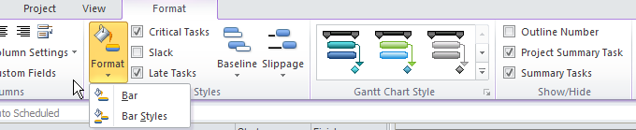

Change the color of the Gantt bar in the Middle section of the Format bar box.

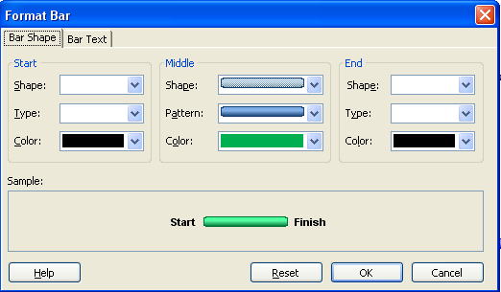

To add the Start date to the left side of the bar and the finish date to the right side of the bar:

* Click **Bar Text** tab
* Click the Left box and select **Start**
* Click the Right box and select **Finish**
* Click OK to close

Note the suggested changed format image at the bottom of the dialog box.

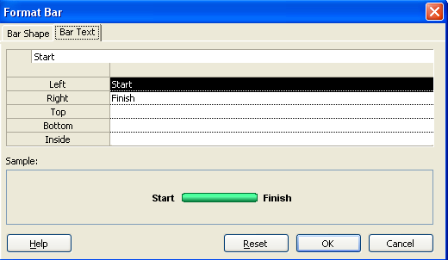

The Gantt bar for the task has been changed to green and the Start and Finish dates for the task are displayed on either side of the Gantt bar. The result of this formatting can be seen in the view below:

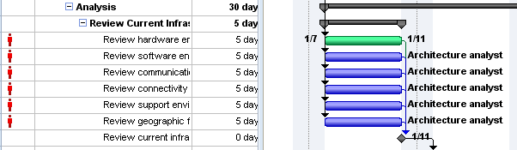

**Bar styles for all Gantt bars** - used to change the formatting in a Gantt chart view or add additional bars to a Gantt chart. Changes using the Bar Styles box will affect all Gantt bars for a specific Gantt chart view.

* Show the Gantt Chart view (or any other Gantt view you wish to change)
* Click **Format 🡪 Bar styles**
* Alter settings as needed – click on a category in the top section, then click in the bottom section to make changes
  + Top section is used to customize the values of a category of Gantt bars
  + Bottom section has two sections:
    - Bars – change bar formatting
    - Text – alter text values around the Gantt bars
* Click OK to close the box

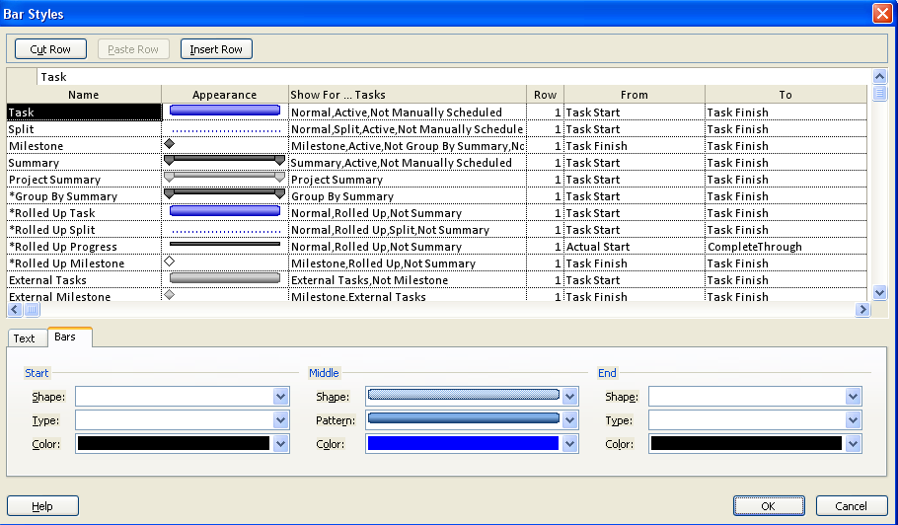

**Scheduling styles -** used to style changes formatting to all Gantt bars for a specific Gantt chart view.

* Display the Gantt Chart view, click the **Format** tab
* Click the slider to view all style selection options
* Click on a style option to be applied to the Gantt chart view

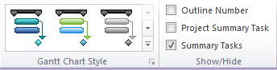

Below is the result of a Gantt chart that has been formatted using one of these styles:

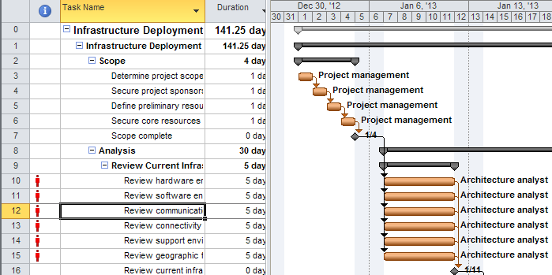

On the left side of the Format bar are 3 buttons used for formatting the text of tasks, gridlines and the Gantt chart layout.

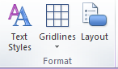

**Text styles:**

The Text Styles formatting tool will format the text of tasks for tables based on a field value selected or for all task types for a specific Gantt chart view or table. There is also the ability to highlight a specific task. In the example, all milestone tasks will appear in red type with a light blue background.

**To apply customized formatting based on a field value:**

* Display a task table view
* **Format 🡪 Text Styles** to open the Text Styles dialog box
* Item to change: **Milestones**
* Color: **Red**
* Background color: **Light blue**
* Click **OK** to close

The box below is shown with these choices:

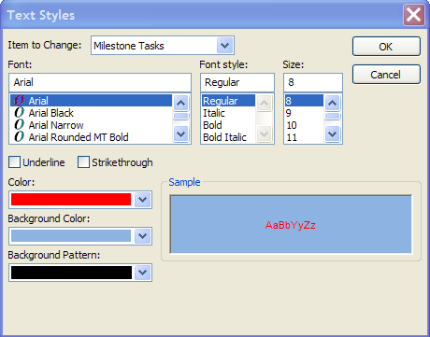

The result of this formatting is shown below.

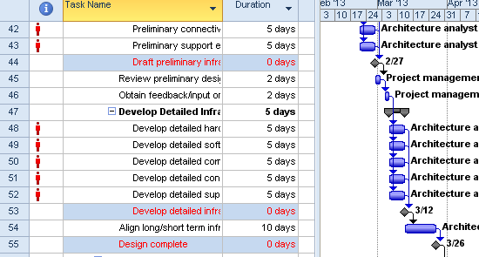

To reset the formatting to normal state for all tasks:

* Display a task table view
* **Format** 🡪 **Text Styles**
* Item to change: **All**
* Color: **Automatic**
* Background color: **Automatic**
* Click **OK** to close

Suggestions for effective use of Text Styles:

* Format all critical tasks
* Color coding of summary tasks
* Highlighting specific tasks during presentations
* Marked tasks- using the field called Marked to mark selected tasks then change formatting based on this coding.

**Gridlines -** used to format the gridlines of a Gantt chart view and tables. In the following example the Project Finish date will be displayed as a blue line:

**To change the color of gridlines on a task table for Gantt chart:**

* Display a task table and Gantt chart
* **Format 🡪 Gridlines**
* Line to change: **Project Finish**
* Type: select a line style
* Color: Blue
* Click **OK** to close

The box below is shown with these choices:

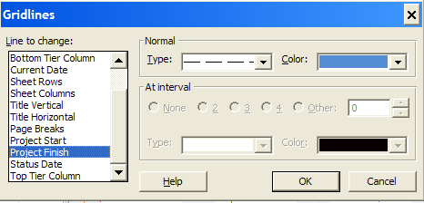

The result of this formatting is shown below. The Project Finish date is highlighted:

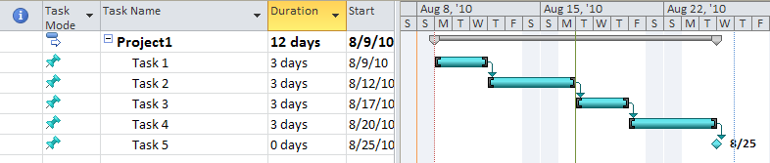

Suggested uses for gridline formats are:

* Status Date
* Current date
* Project Start date
* Project Finish date

**Layout**

Layout is very helpful in customizing several features shown in Gantt chart views.

* Format 🡪 Layout

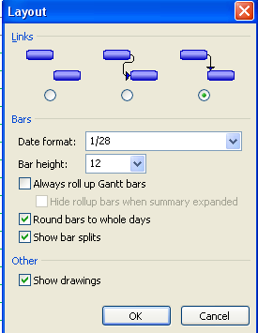

* **Links -** used to change the look of the link lines or turn them off.
* **Date format -** used to change the date format on the Gantt chart and will not affect the date shown in the tables.
* **Bar Height -** used to adjust the Gantt bars.
* **Always roll up Gantt bars –** used to roll up the Gantt bars when the outline level is collapsed, roll up the Gantt bars (example of rolled up bars is shown below).
* **Round bars to whole days –** used to make very short tasks more visible.
* **Show bar splits -** used when you have split tasks. Split tasks will also appear during tracking.
* **Show drawings –** drawing tools are located on the Format tab. Text boxes and arrows may be drawn on Gantt charts. Use this option to hide the drawings when needed.

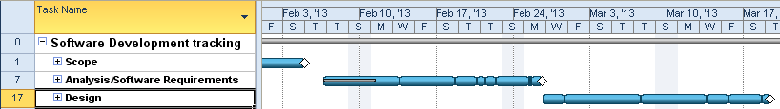

**NOTE:**  Using the Gantt Chart Wizard, you can reset the Gantt chart formatting to its default settings. Gantt Chart Wizard must be added to a ribbon before you can use it. The Gantt Chart Wizard contains several additional formatting styles.

## Customizing Timeline Views



The Timeline view is new view to Project 2010. The purpose of the Timeline view is to display project tasks using a timeline format and export the view to other applications such as Word, Excel, Outlook and Powerpoint.

Gantt Chart with Timeline is the default view in Project 2010. This view is a split screen with the Timeline view on the top and the Gantt Chart View on the bottom.

**To turn Timeline view off/on:**

* **Task 🡪 Gantt Chart**
* **View 🡪 Timeline**

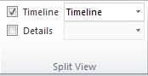

Below is a view of the default Timeline view. The Timeline view is showing the information for the project summary task. The length of the timeline represents the duration of the project. There is a timeframe window open in the middle to highlight a specific timeframe:

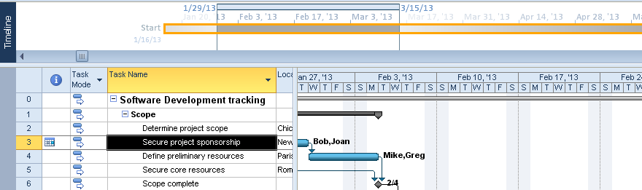

**To format or add more data to the Timeline view:**

* Click inside the Timeline view window
* Click on the Format tab

Below is a view of the Timeline format bar. Use the buttons on this bar to add additional tasks and format the Timeline view.

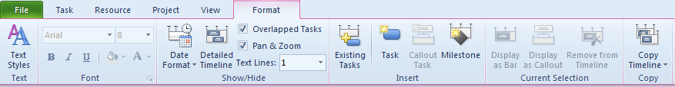

Within the Timeline view there is a timeframe window highlighted in the diagram below.

* The Timeframe window may be dragged left and right to emphasize different timeframes of the project schedule. The Gantt bars will adjust as the timeframe window is moved.
* Change the timeframe window by clicking in the timeline view and clicking the zoom slider in the lower right corner of the screen.
* The time density of the Timeline view does not have to match the time density of the Gantt Chart View.
* To turn on and off the Timeframe window, click the Pan & Zoom button on the Format bar.
* Use the Date format button on the Format bar to format the dates in the Timeline view.
* Use the Detailed Timeline button to show task names and dates in the view.

The view below shows the standard Timeline view with the Gantt chart view below. The Timeframe window is highlighted:

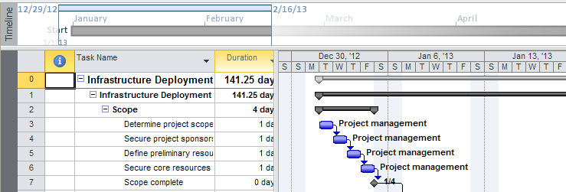

Adding additional tasks to the Timeline view will help build a better picture of your project. Tasks can be individually included to the Timeline view via the Task Information dialog box under the General tab. Double click a task to display the Task Information dialog box.

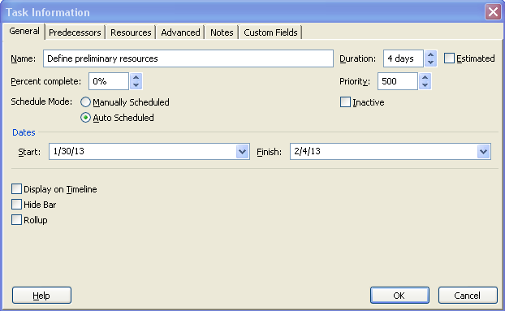

The timeline format bar has several command buttons that will help flag tasks for inclusion into the Timeline view. Clicking the Existing Tasks button will display a list of all tasks for a project where you can scroll through and select the tasks you want displayed in the Timeline view.

**To add tasks to the timeline view using the Existing Tasks button:**

* Click **Existing Tasks**
* Using the check boxes, select the tasks to add
* Click **OK** to close.

See below for an example of the Existing Tasks choice list. It is easy to tell the difference between summary and detail tasks:

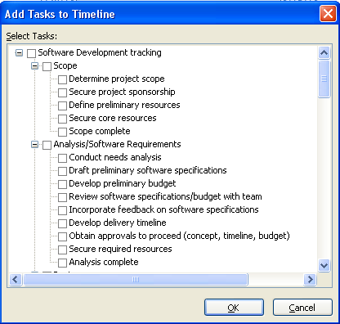

The timeline view should be planned carefully to create a meaningful report. Too much information can confuse the reader. Consider creating a high level tasks report that shows sections of work planned to be completed within timeframes. Below is a view where outline Level 1 tasks have been added to the Timeline view.

**To add Outline Level 1 tasks (Summaries) to the Timeline view:**

* **Tasks 🡪 Gantt Chart**
* **View 🡪 Outline 🡪 Outline level 1**
* For each summary task to be added to the Timeline view, Select and Right click. Multiple selections maybe made.
* Click **Add to timeline**

The Timeline view below, displays Outline Level 1 Summary tasks only and the Gantt chart displays the same Outline Level 1 Summary tasks.

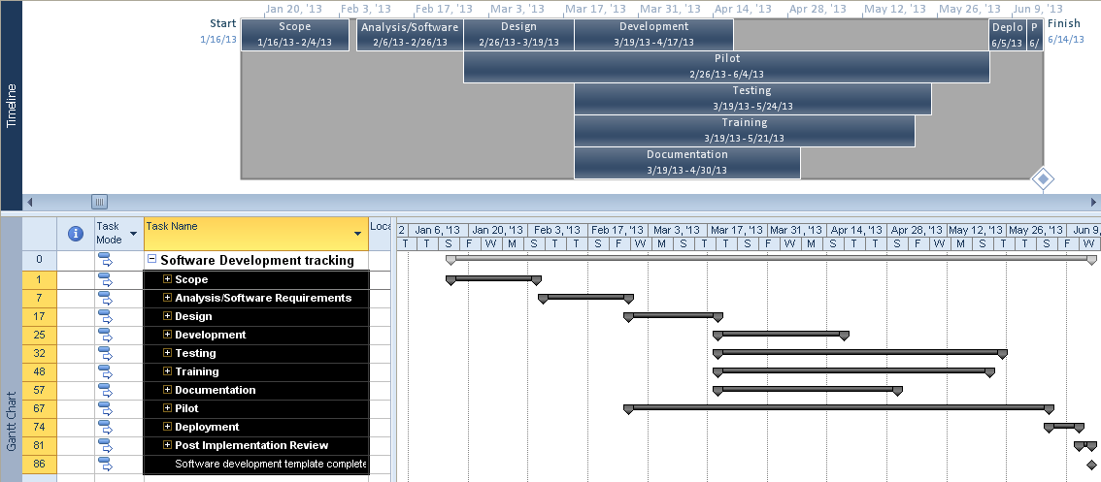

Milestone can also be added to the Timeline view.

**To add a milestone to the Timeline view:**

* **Tasks 🡪 Gantt Chart**
* **View 🡪 Filter 🡪 Milestone**
* Select the milestone tasks and Right click
* Click **Add to timeline**

The diagram below displays Outline Level 1 tasks with milestones added:

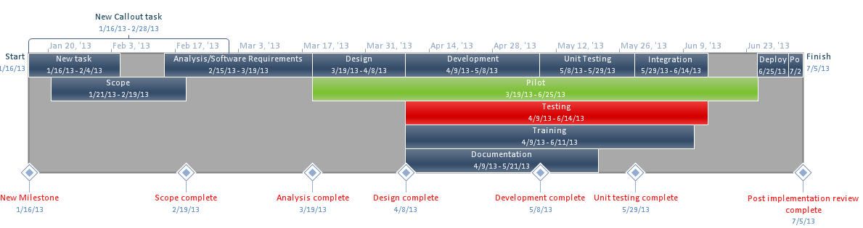

Tasks may be added to the project using the Timeline view format bar. When adding tasks using these buttons, the tasks will be added to the end of the project schedule and will start on the first day of the project or the current date depending on the scheduling option. The choices are:

* Adding a new task to the timeline
* Adding a new callout task to the timeline
* Adding a new milestone to the timeline

Below is a view showing a new task, a new callout task and a new milestone added to the timeline and the project schedule. The lower half of the view shows the tasks added to the Gantt Chart view. Callout tasks are originally placed above the timeline spanning the timeframe of the task. After they are created, they may be dragged to alternate locations within the Timeline View.

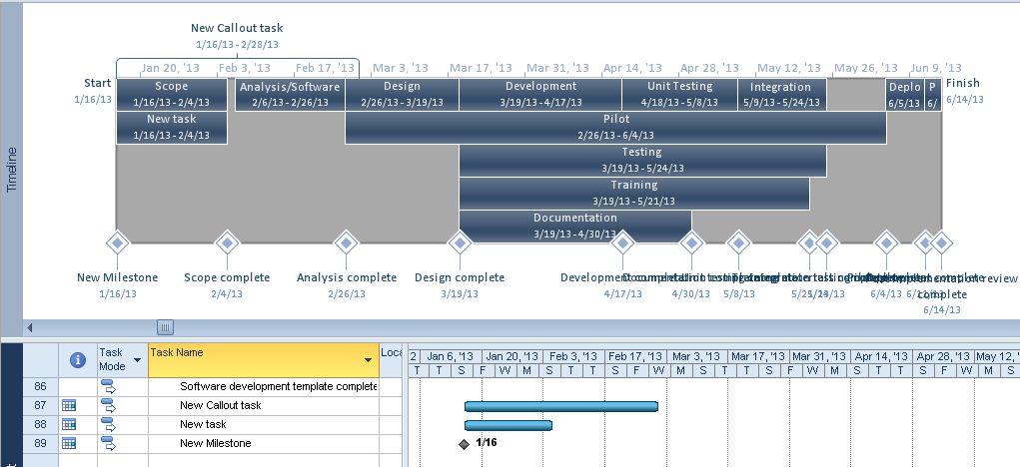

**To display an existing task as a callout task:**

* Click on a task in the Timeline view
* Click **Display as a Callout**

**To display a Callout task as a bar:**

* Click on the Callout task
* Click **Display as Bar**

**To remove tasks from the Timeline view using the Timeline format bar:**

* Click the task in the Timeline view
* Click **Remove** **from Timeline**

Tasks may be formatted and highlighted as necessary. Text styles and format buttons are available on the Timeline format bar. Tasks may Changing the colors of the timeline bars is helpful when highlighting information.

**To export a Timeline view to Outlook, Excel, Word, or Powerpoint to the clipboard:**

* Click in the **Timeline** view
* Click **Copy timeline**
* Select copy choice:
  + For email
  + For presentation
  + Full size
* Navigate to destination
* Click **Copy**

**Best Practice**: *Too much information results in a hard to read Timeline view. Select what is important and what will convey your message. The view will become more meaningful and will result in a useful reporting tool.*

## Practice: Customizing the User Interface



*The Practice page is where you write detailed instructions for completing work listed as Exercises.*

*Type the Exercise Title and write a brief summary what the student will be doing in the exercise. Then list your ideas what they will be doing.*

*SAMPLE*

*In this practice you will create a Project Server Authentication profile and then configure the local cache settings in Project Professional 2007.*

*Exercise 1: Create Project Server Authentication Profile*

*In this exercise you will create Project Server authentication profile to connect to the Project Web Access site.*

Perform the following exercise on the PS07 virtual machine.

1. *From the* ***Start*** *menu, click* ***All Programs*** *🡪* ***Microsoft Office*** *🡪* ***Microsoft Office Tools*** *and click* ***Microsoft Office Project Server 2007 Accounts****.*
2. *In the* ***Project Server Accounts*** *dialog box, click* ***Add****.*
3. *In the* ***Account Properties*** *dialog box, and complete the following settings and click* ***OK****.*

|  |  |
| --- | --- |
| *Setting* | *Perform the following:* |
|  | |
| *Account Name* | *Type* ***Project Server*** |
| *Project Server URL* | *Type* ***http://epm/pwa*** |
| *When connecting* | *Select* ***Use Windows user account*** |
| *Set as default account* | *Select check box* |

# Lesson 3: Working with the Organizer



Fields, tables and views are in Project 2010 are called objects. Creating objects is easy and can be very powerful. Creating objects is a way of getting the information you need from your unique project schedules. Objects may be created for one specific project schedule or may be saved for reuse in other projects. To retain objects they must be copied into the Global.mpt using a tool called the Organizer.

In this lesson, we will talk about:

1. What is an object.
2. What types of objects are available.
3. Define settings for using the Organizer.
4. Sharing objects between projects.

## What is an Object & What Objects are Available



A project schedule might have tasks occurring in different locations. Reporting tasks by location would help to communicate information regarding the project more accurately. To allow for this type of reporting a task field could be created to contain the location information. The created field is called an Object.

An object is an element of Project 2010 which can be standard to Project 2010 or is custom created for use in a project schedule. Standard objects which are contained in Project 2010 may be altered as needed and saved. Once an object is created or a standard object changed, objects may be available for use in one unique project schedule or can be shared for use in other projects. Objects may be copied between project schedules to enable sharing among projects and other Project 2010 users. All objects are stored in the Global.mpt file that was created when Project 2010 was installed.

**Available Objects:**

|  |  |
| --- | --- |
| **Object** | **Available for** |
| Filters | Resource and Task |
| Groups | Resource and Task |
| Import/Export Maps | Both |
| Tables | Resource and Task |
| Reports | Both |
| Views | Resource and Task |
| Calendars | Project level |
| Modules (Macros) | Both |
| Fields | Resource and Task |

**Best uses for objects:**

* Calendar – create it once and apply to future projects.
* Establishing a standard process for project schedules.
* Project managers can use the same value fields to collect common data.
* Projects may be combined and data reported across multiple projects.
* Creating unique values that apply to an individual project.
* Creating standardized reports for use with all projects.

**TIP:**  *A custom view may be a combination of a customized table, filter and group. Reports may contain tables and filters. Tables may contain fields. All pieces of the custom object must be copied individually using the Organizer into the Global.MPT. Project 2010 is not aware of dependent objects. All children objects must be copied for the parents to function.*

## Define Settings in Organizer



When objects are created using Project 2010, they will be placed either in the global value for the project file in which they were created or in the Global.mpt file. A new display option in Project 2010 allows objects to be automatically added to the local Global.mpt. Some objects such as import/export maps and macros (modules) will automatically be placed in the Global.mpt.

**To display the Display options:**

* **File 🡪 Options 🡪 Advanced**

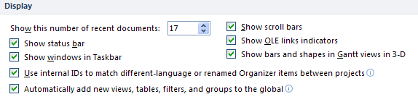

## Using the Organizer to Share Objects



Across the top of the Organizer dialog box are multiple tabs for the different types of objects used by Project 2010. The box to the left displays all Global.MPT values and the box to the right displays values specific to the open project file. Use the organizer to copy objects between projects or into the local Global.MPT file.

**To display the Organizer:**

* File 🡪 Info 🡪 Organizer

**To copy an object from a particular project schedule to the Global.MPT:**

* Click on the object in the pane to the right
* Click **Copy** to copy the object to the Global.MPT on the left

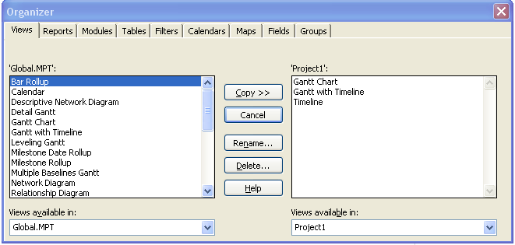

The two “Views available in” boxes at the bottom of the Organizer box will allow for selecting objects from alternate open project schedules.

**TIP:** *The Organizer is also used to rename and delete objects from Project 2010.*

## Practice: Working with the Organizer



*The Practice page is where you write detailed instructions for completing work listed as Exercises.*

*Type the Exercise Title and write a brief summary what the student will be doing in the exercise. Then list your ideas what they will be doing.*

*SAMPLE*

*In this practice you will create a Project Server Authentication profile and then configure the local cache settings in Project Professional 2007.*

*Exercise 1: Create Project Server Authentication Profile*

*In this exercise you will create Project Server authentication profile to connect to the Project Web Access site.*

Perform the following exercise on the PS07 virtual machine.

1. *From the* ***Start*** *menu, click* ***All Programs*** *🡪* ***Microsoft Office*** *🡪* ***Microsoft Office Tools*** *and click* ***Microsoft Office Project Server 2007 Accounts****.*
2. *In the* ***Project Server Accounts*** *dialog box, click* ***Add****.*
3. *In the* ***Account Properties*** *dialog box, and complete the following settings and click* ***OK****.*

|  |  |
| --- | --- |
| *Setting* | *Perform the following:* |
|  | |
| *Account Name* | *Type* ***Project Server*** |
| *Project Server URL* | *Type* ***http://epm/pwa*** |
| *When connecting* | *Select* ***Use Windows user account*** |
| *Set as default account* | *Select check box* |

# Lesson 4: Creating Custom Objects



Objects offer the Project Manager significant flexibility for creating customized and meanginful project reports. Each project is different and objects may be created for one unique project or copied using the Organizer for use in existing and future projects.

In this Lesson, we will discuss:

1. Creating custom fields.
2. Creating custom filters.
3. Creating custom groups.
4. Creating custom tables.
5. Creating custom views.

## Creating a Custom Field



Project 2010 provides over 100 fields in the Task and Resource data sections that are available for use by the project scheduler. Customized or free-use fields are available in different data types. When creating a customized field, the type of data stored in the field and how the field will be used will determine the data type selected.

Below is a list of the customizable fields available in Project 2010. The same set of fields is available in both the Task and Resource data sections:

|  |  |  |
| --- | --- | --- |
| Field name | Field type | Number of available fields |
| Text1- Text 30 | Text | 30 |
| Duration1 – Duration10 | Time | 10 |
| Number1 – Number 10 | Numeric | 10 |
| Date1- Date10 | Date | 10 |
| Finish1 – Finish10 | Date | 10 |
| Start1 – Start10 | Date | 10 |
| Flag1 – Flag10 | Yes/No | 10 |
| Cost1 – Cost 10 | Monetary value | 10 |
| Outline1 – Outline10 | Hierarchical structure - Text | 10 |

Custom fields are very flexible and can contain one or more of the following traits:

* Lookup table
* Formula
* Graphical indicators
* Data

To create a custom field, follow the steps below. In this example, a custom field called Location will be created with a lookup table.

**To display the Custom Fields dialog box:**

* **Project 🡪 Custom Fields**  
    
  - OR -
* Right click any field name and select **Custom Fields**  
    
  The following Custom Fields dialolg box will appear:
* Type: Select **Text**
* Select one of the unused fields available  
    
  NOTE: *A field that has been used will display the name the field was changed to.*

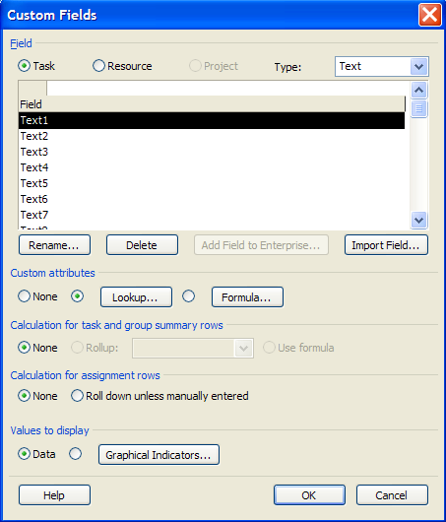

* Click **Rename**
* Type **Location**  
  **NOTE:** *Field names must be unique*
* Click **OK** to close

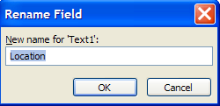

When a field is renamed, the old name will be shown following the new name in parenthesis. When using the field either name may be used to refer to the field.

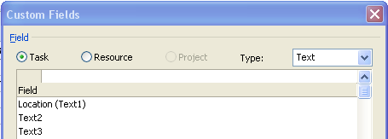

The next steps will create the Lookup table used to standardize the data entered into the Location field. Several values have been added in the view below:

* Click **Lookup** (box below will appear)
* In the value column on the left, enter the Lookup table values – repeat to complete the list
* In the description on the right enter a description for the Lookup table value (optional)
* Check box to set one of the values as a default value (optional)
* Click radio button to sort the list (optional)
* Check box to allow user to add values to the list (optional)
* Click **Close** to close
* Click **OK** to close the Custom Fields box

**NOTE:**  *Lookup tables may be imported from other projects or imported between task fields and resource fields.*

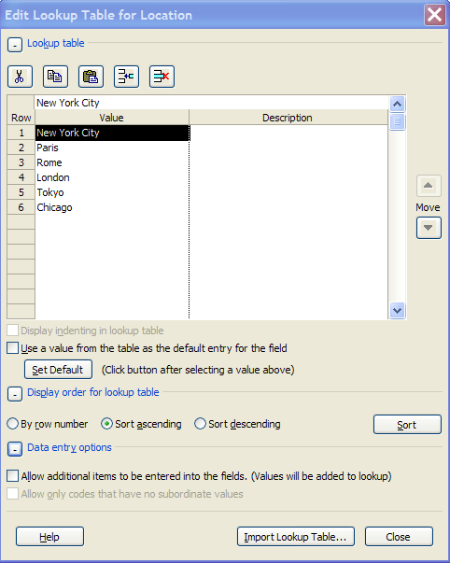

To use the newly customized field above, insert the field into a Task table. A pull down list is now available to access the Location lookup table of values. The result is shown in the view below:

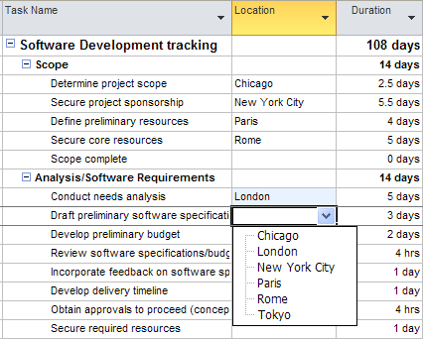

To save the newly created field for use in existing and future projects:

* **File 🡪 Info 🡪 Organizer**
* **Fields** tab
* Click on the Location field in the right pane
* Click **Copy** in the middle to copy the object into the Global.mpt in the left pane

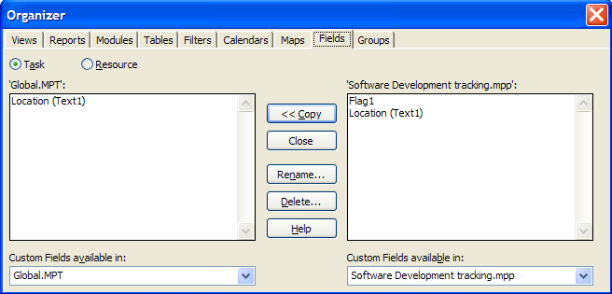

**TIP:**  *The Task Information box and the Resource Information box contain tabs called “Custom Fields”. Accessing the custom fields through the information boxes will display all custom fields available in either of the data sections and offer an easy access point.*

**NOTE:**  *Not all custom field capabilities could be addressed in the framework of this course. Formulas are very helpful for calculating values between fields. Graphic indicators may be used to create stop light reports. Further information on custom field values can be found in a complete Microsoft Project 2010 reference book.*

## Creating a Custom Filter



Filters offer a useful means of filtering out unwanted data, thereby retaining only the data you need to see. As part of the standard software Project 2010 contains with over 30 standard filters. Filters can be applied to tables, reports and views to return specific data for reporting purposes. Custom filters can also be created using standard or customized fields.

With the numerous built-in filters available in Project 2010 it is a good practice to verify the standard filters before creating a new custom filter to see if the filter you require has already been provided.

In the following example, a filter will be created to filter for automatic scheduled tasks:

**To create a custom filter:**

* **View 🡪 Filter 🡪 New Filter**

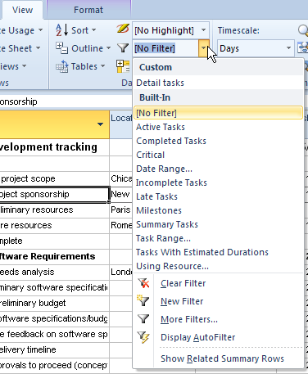

The Filter definition box will appear, shown below. The following enteries are made:

|  |  |
| --- | --- |
| Field | Entry |
| Name | Automatic Scheduled Tasks |
| Show in the menu | Check to turn on |
| Field name | Task Mode |
| Test | Equals |
| Value | Auto Scheduled |
|  | Save |

The completed box is shown below:

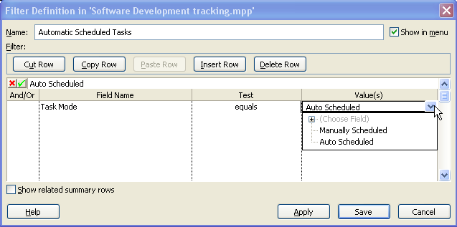

Created custom filters are added to the list of Custom filters in the filter drop down selection box. Click on the new filter to apply it. F3 key or Clear Filter to remove the applied filter and reset the data to the pre-filtered state. The new filter entry is shown below:

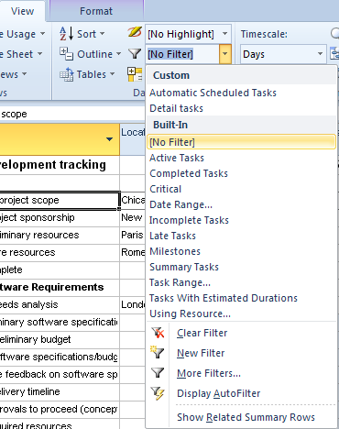

## Creating a Custom Group



Categorizing tasks, resources or assignments by specific column values is called Grouping. As discussed earlier, Project 2010 provides many standard groupings. Custom groupings may be created using custom or standard fields. Groups can use up to 10 levels of detail.

**To create a custom group:**

In the following example, a group is created using the Location field from the previous lesson.

* **View 🡪 Group 🡪 New Group by**

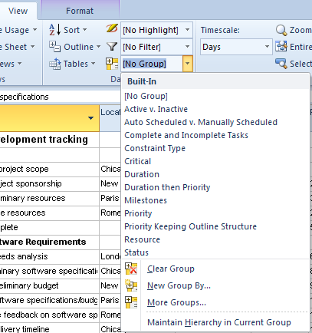

The following enteries are shown in the view below.

* Name: **Location**
* Show in menu: **Checkmark**
* Group by: **Location**
* Click **Save** to close

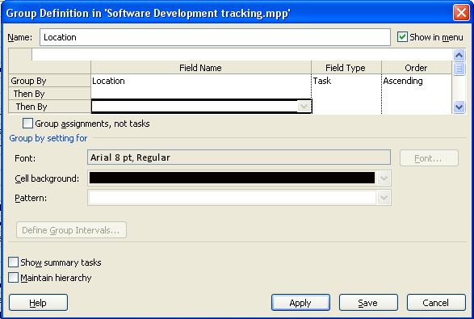

The resulting grouping is shown below:

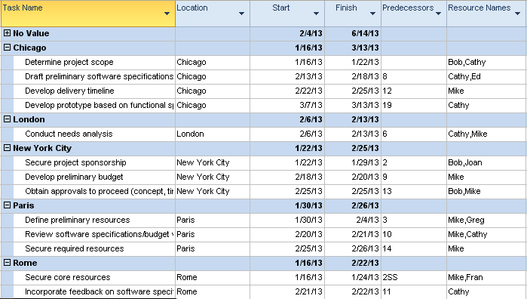

NOTE: *The option to show the summary tasks is turned off. When the grouping is removed, the summary tasks will be displayed.*

**To remove an applied grouping and reset data to a pre-grouped state:**

* **View 🡪 Groups 🡪 No Group or Clear Group**

**A gr**o**uping by** **Start or Finish date is** very helpful for focusing on short-term timeframes, particulary for large schedules or schedules with multiple parallel paths.

**To create a grouping by Start date for per week time intervals:**

* **View 🡪 Group 🡪 New group by**

Enter the following values:

* Name: **Start by Week**
* Group by: **Start**
* Click **Define Group Intervals**

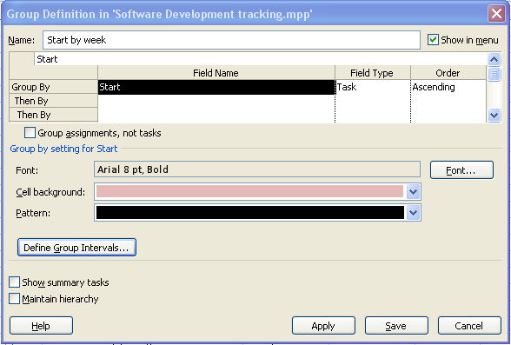

Select:

* Group on: **Weeks**
* Group Interval: **1 (weekly)  
  Note:** *Selecting 2 would result in bi-monthly grouping of the data*
* Click **OK** to close
* Click **Save** to close Group Definition dialog box

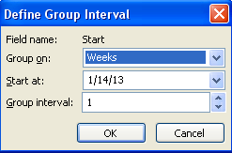

An example of a weekly grouping is shown below

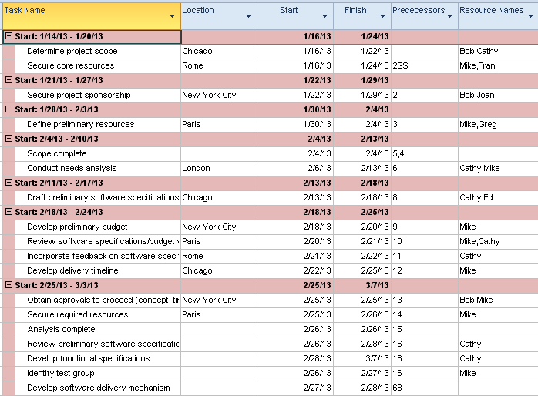

To collaspe the weeks and summarize the report (shown below):

* View 🡪 Outline 🡪 Outline Level 1

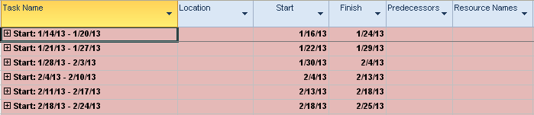

TIP:

* Using the weekly grouping and displaying the Cost table will provide weekly cost totals.
* Creating a grouping by Finish date will show which tasks are scheduled to complete in timeframes by week. This will provide an easy way to know when tasks will need status checking.

## Creating a Custom Table



Tables are the foundation for views and reports. Project 2010 contains multiple tables for tasks and resources based on topic areas. Consider these standard tables as topical starting points and are intended to be customized by users to their needs. Columns may be added and deleted as necessary for reporting or data input.

**Best Practice:** *copy a table and make changes to the copy*

**To copy a table:**

* **View 🡪 Tables 🡪 More tables**
* Select a table
* Click **Copy**

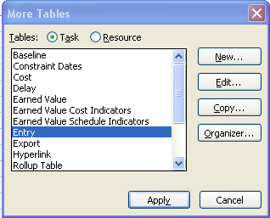

In the example below, a copy of the Entry table will be altered. The Predecessor column will be deleted and the Work column added. In addition, the Start column will be resized to 10 characters. The following table shows the keystrokes to accomplish these changes. The completed view is shown below:

|  |  |
| --- | --- |
| Field | Action |
| Name | Duration and Work Table |
| Show in menu | Check on |
| In the field name column, click on Predecessors | Click Delete row |
| In the field name column, click on Start | Click on Insert row, click on “Wo”, select Work |
| Click on the width for the start column | Change 16 to 10 |
| Click OK | Close the box |

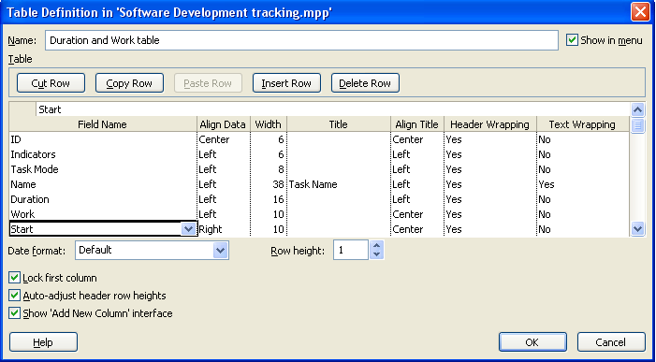

Below is the table view as defined above:

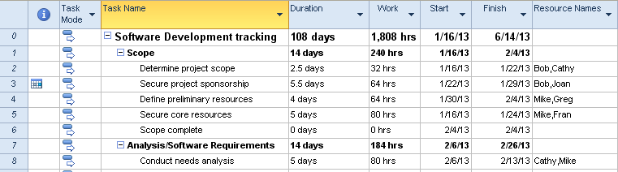

Project 2010 provides a new method of creating tables. When columns are added to standard tables, the resulting table could be saved.

**To save a table that has had columns added:**

* **View 🡪 Table 🡪 Save Fields as New Table**

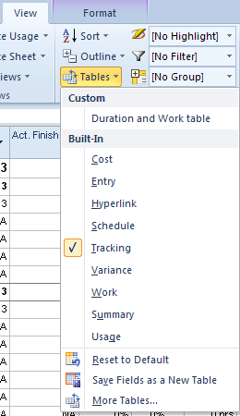

* Select **Update Current Table** or **Save as New Table**
* Enter new table name
* Click **OK** to close

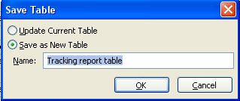

**TIP:** *changes made to tables will be reflected in the table definition. If the value #### appears in a column it will indicate that the column content exceeds the width of the column. Double click between the column headings to auto adjust the width of the column to the width of the contents of the columns.*

## Creating a Custom View



Project 2010 provides the ability to create views to put appropriate information in front of the project manager as needed. Views can be created from copies of existing views or new views may be created. To avoid overwriting an existing view, make a copy of a view and use the copy for edits. In the More Views box below, note that a Copy button is provided on the right side of the box for this purpose. Filters, groups and tables can be incorportated into custom views. Split screen or single views may be created.

**TIP:**  *view names must be unique*

**To create a new single view:**

* **View (Resource or Task) 🡪 Gantt Chart 🡪 More Views**
* Click **New**
* Select **Single** or **Combination** **view** (split screen)
* Click **OK**

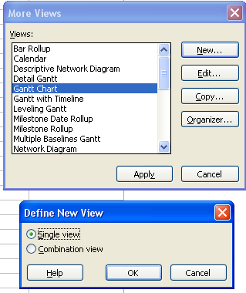

The following field values were entered in the view below:

|  |  |
| --- | --- |
| Field | Object |
| Name | PM Gantt chart view |
| Screen | Gantt Chart |
| Table | Duration and Work table |
| Group | Start by week |
| Filter | Automatic scheduled tasks |
| Show in menu | New view will appear in the short menu for views |

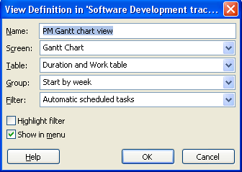

The result of the “Show in the menu” option is shown below:

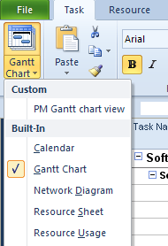

The resulting view will appear as shown below:

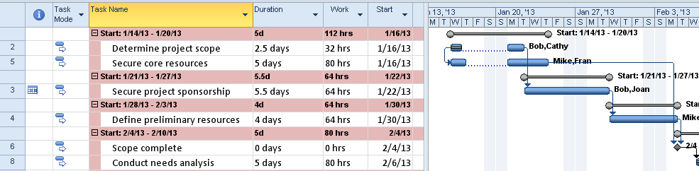

## Practice: Creating Custom Objects



*The Practice page is where you write detailed instructions for completing work listed as Exercises.*

*Type the Exercise Title and write a brief summary what the student will be doing in the exercise. Then list your ideas what they will be doing.*

*SAMPLE*

*In this practice you will create a Project Server Authentication profile and then configure the local cache settings in Project Professional 2007.*

*Exercise 1: Create Project Server Authentication Profile*

*In this exercise you will create Project Server authentication profile to connect to the Project Web Access site.*

Perform the following exercise on the PS07 virtual machine.

1. *From the* ***Start*** *menu, click* ***All Programs*** *🡪* ***Microsoft Office*** *🡪* ***Microsoft Office Tools*** *and click* ***Microsoft Office Project Server 2007 Accounts****.*
2. *In the* ***Project Server Accounts*** *dialog box, click* ***Add****.*
3. *In the* ***Account Properties*** *dialog box, and complete the following settings and click* ***OK****.*

|  |  |
| --- | --- |
| *Setting* | *Perform the following:* |
|  | |
| *Account Name* | *Type* ***Project Server*** |
| *Project Server URL* | *Type* ***http://epm/pwa*** |
| *When connecting* | *Select* ***Use Windows user account*** |
| *Set as default account* | *Select check box* |

# Summary



The customizing features of Project 2010 are extremely flexible and are limited only by the Project Manager’s imagination. Use these objects to create customized data for an individual project or complete processes for an organization. Store the objects in one project schedule, use for all your project schedules or share with other users. Deciding what information is required will be harder than defining the objects themselves.

In this Module, we discussed:

1. Customizing the ribbon bar.
2. Export/import customized ribbon bars.
3. Customizing views.
4. Retaining customized objects using the Organizer.
5. Creating custom objects.